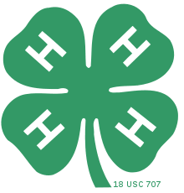
2024 Ness County Fair Schedule

Saturday, July 20th
8:00am Pre-Fair Setup for Fair Board and 4-H Families

Monday, July 22nd
9:00am 4-H Clothing and 4-H Photography Judging NCGS
7:00pm 4-H & Open Horse Show

Tuesday, July 23rd
5:30pm Parade Entry & Line-up
6:00pm Parade Start
6:30pm Watermelon Feed
7:00pm Barn Quilt Parade and Auction
7:00pm Best Barn Creations (gingerbread, Lego, etc.)

Wednesday, July 24th
8:00am - 10:00am 4-H and Open Class indoor exhibit entries taken in
9:00am - 8:00pm 4-H Concessions stand open
9:00am 4-H Foods Judging
10:00am All 4-H and Open Class indoor exhibit judging
11:30am Cloverbud Judging at the East end of the Booth Building
1:00pm 4-H Visual Arts Judging
5:00pm All 4-H Livestock needs to be in place
6:00pm 4-H Foods Auction and Public Style Review
7:00- 10:00pm Ness Co Amusement Company Open
7:30pm Ice Cream Social @ Fairgrounds
8:00pm Gospel Concert Featuring, Mark 209
(Sponsored by Ness County Area Churches)

Thursday, July 25th
8:00am - 9:30am Livestock Weigh in (Goats & Beef weight-in1st then Swine)
9:00am Rabbit, Poultry, Pets, and Dog Show
9:00am - 8:00pm 4-H Concessions Stand Open
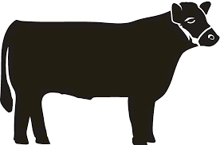
6:00pm Free Will Donation Meal by Ness City Fire Department
700pm KWHA Horse Show

Friday, July 26th
9:00am Swine, Sheep & Goat Show
9:00am - 8:00pm 4-H Concessions Stand Open
5:30pm GBT Free Hot Dog Feed
6:00pm Beer Garden Opens
6:00pm Kids Rodeo Registration
7:00 – 10:00pm Ness Co Amusement Company Open
7:00pm Kids Rodeo @ Arena
8:00pm - 12:00am KZNC Party DJ’s

Saturday, July 27th
6:30am 5K Color Run Registration
7:00am 5K Color Run Begins
8:30am Mud Volleyball Registration/Check in
9:00am Start Mud Volleyball
9:00am Round Robin Contest -Agricultural Demonstrations immediately following (AI a Heifer, Milk a Dairy Cow, Poultry/Rabbit Showmanship)
9:00am - 8:00pm 4-H Concessions Stand Opens
10:30am Cornhole Registration
11:00am Cornhole Contest Begins
12:30m Buyers/supporters Appreciation meal
1:00pm Livestock Auction/4-H Awards
Livestock Dismissal following the auction
5:00 Farm Bureau Family Games
6:00pm Beer Garden Opens
6:00pm Kids Pedal Pull, Registration, Pull at 6:30pm
7:00pm NBHA Barrel Race
7:00 – 10:00pm Ness Co Amusement Company Opens
8:00pm - 12:00pm Free Concert-Crazy Horse 2.0

Sunday, July 28th
8:00am Post Fair Clean-up

7:00pm 4-H Beef Show/Old Timers Showmanship
7:00-10:00pm Ness Co Amusement Company Open

